

Solution Architecture

Date | 29 June 2026
Team ID | xxx
Project Name | Smart Lender
Maximum Marks | 5 Marks

Solution Architecture Diagram:

The Smart Lender – Loan Eligibility Prediction System follows a layered architecture to ensure efficient, secure, and scalable loan eligibility prediction. Users interact with the system through a Flaskbased web interface, where applicant details are entered. The requests are processed through the application layer, which performs data validation, preprocessing, and machine learning prediction using the trained XGBoost model. The business logic manages the prediction workflow and communicates with external services when required. Finally, the data layer stores the loan dataset, trained machine learning model, prediction results, and application logs. This architecture enables fast, reliable, and realtime loan approval predictions while maintaining data integrity and system performance.

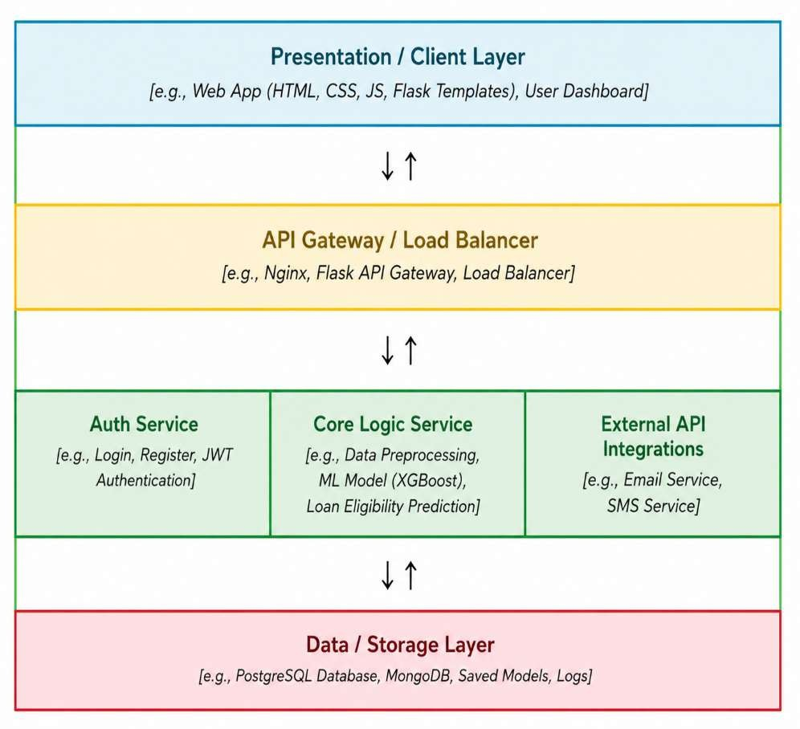

Component Description Table

Component Name | Description / Role in Architecture | Technologies Used
Presentation / Client  Layer | Provides a user-friendly interface where applicants enter loan details and view the loan eligibility prediction result. | HTML, CSS,  JavaScript, Flask  Templates
API Gateway /  Application Layer | Receives user requests, validates input, and forwards the data to the machine learning prediction service. | Flask, Python
Core Logic Service | Performs data preprocessing, feature encoding, and executes the trained XGBoost model to predict loan eligibility. | Python, Scikit-learn,  XGBoost, Pandas,  NumPy
External API  Integrations | Supports future integration with banking systems, credit verification services, or notification services if required. | REST APIs (Optional)
Data / Storage Layer | Stores the loan dataset, trained machine learning model, prediction results, and application logs. | CSV Dataset, Pickle  (.pkl), IBM Cloud  Storage

